**New year’s Eve**

**up , out, turnout, sold, turn**

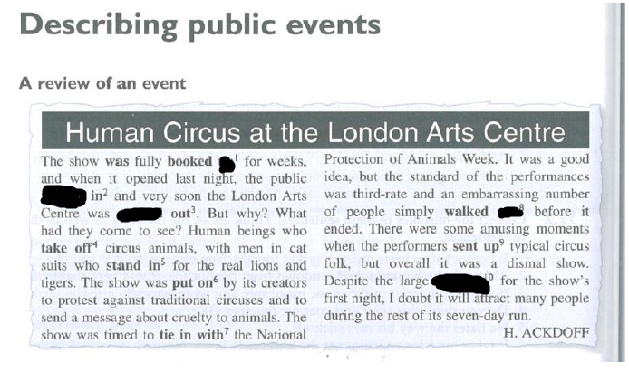

**tipsy , flood , surpass , vivid , mixed , plastered , appeal, , whale, overwhelmed , jaw-dropping ,light up, squeeze , scatter, buzzing , beverages, wild , resolutions**

A lot of people were ………………………after New Year’s eve party .

That performance was extraordinary It ……………………………………………my expectations

I ………………………New Year as I hope it will be more promising , prosperous and abundant in

When you …………………………..fireworks you need to cautious not to burn your hands

I have ……………………………….feelings about that concert It didn’t blow me away. It was ok

The band didn’t ………………………………to me personally . It was not my cup of tea

That New Year’s Eve was ……………………………..and ………………………………..I was a bit ……………………..after few shots. Some of my friends got ……………………………..

I was………………………………………by massive fireworks

We had a lot of……………………………… during New Year’s Eve including , whiskey , champagne and soft drinks,

How many ………………………….have you made for upcoming New Year

I had a ………………………………of time at a ball It was stunning

Display of fireworks in London was …………………………………., absolutely spectacular

People …………………………………….into the market square to watch the concert . After the concert they …………………………..in all directions . There was such a ………………………………….that I couldn’t breathe

Phrasal verbs – entertainment

up, off , up , up , up , into , round, up , out, along, off

Our friends brought their family a………………………….. to our house during New Year’s Eve

That party didn’t live ………………………..to my expectations . It was below substandard and dull

Our plan of going out that evening didn’t come ……………………………….due to my husband’s illness

Crowds of people , frost as well as drunkards turn me ……………………………..that’s why I prefer to stay at home

I couldn’t put………………………with her voice so I turned off TV

Are you ……………………….for New Year’s Eve party?

Celebration kicked……………………….at 8 p.m

Fireworks lit …………………………….the sky

Next year I don’t rule………………………………going abroad during New Year’s Eve

If you mishandle fireworks you may burn …………………………..your hands

Some friends came ……………………………..to welcome New Year together